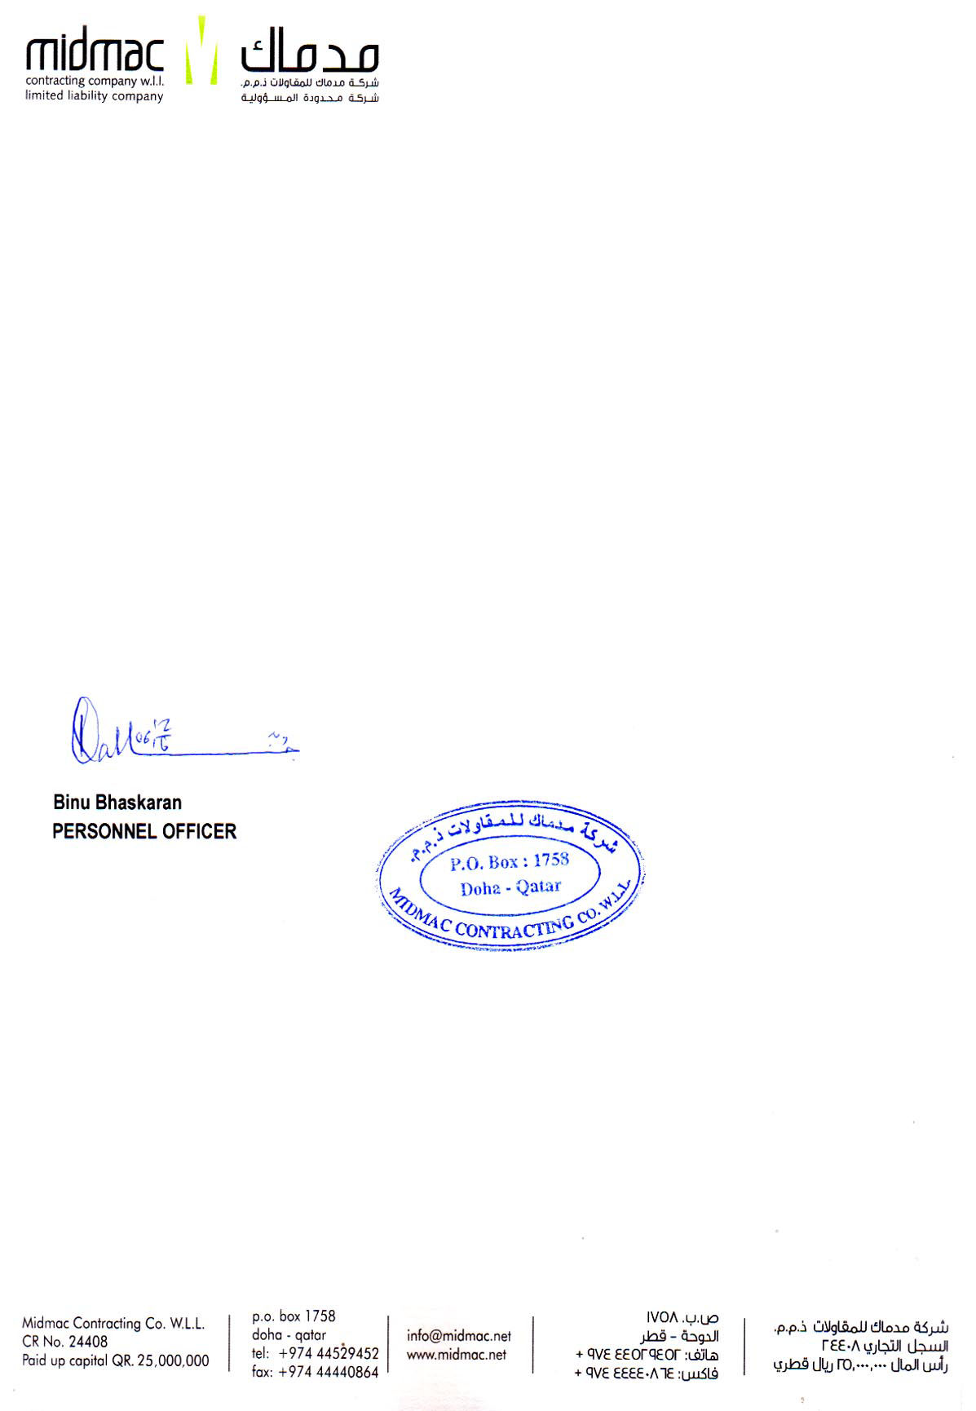

<To>

TO WHOM IT MAY CONCERN

This is to certify that Mr. <Name>, ID No. 29043, holder of Pakistani Passport No. <Passport> has worked with Midmac Contracting Co. W.L.L. from <From> to <To> in the capacity of <Designation>.

For Midmac Contracting Co. W.L.L.